3.1 Introduction
This chapter covers the design framework and development approach used for the Assistive Robotic Arm for People with Limited Mobility. The system is a voice-and-joystick-controlled robotic arm with six degrees of freedom, built around two controllers working together: a Raspberry Pi and an Arduino. The main goal of the arm is to help people who have limited upper-limb mobility carry out everyday tasks like picking up and placing objects, which can go a long way in helping them live more independently.
Designing an embedded robotic system like this one is not straightforward because it cuts across several engineering areas at once, including mechanical design, electronics, firmware, and the interface between the user and the machine. To handle all of this without losing track of how the pieces fit together, a top-down system design approach was used. This basically means the system was first looked at from a big-picture level, figuring out what it needs to do and how the main parts relate to each other, before getting into the finer details of each subsystem. The advantage of doing it this way is that every design decision can be traced back to the overall system requirements, so nothing is designed in isolation or just for the sake of it.
At this stage of the project, work is focused on design and simulation. A wiring schematic has been put together to map out the electrical connections between the Arduino, the Raspberry Pi, the PCA9685 PWM driver, the servo motors, and the joystick. Alongside that, the movement of the arm has been modelled and tested through a simulation using the Niryo Ned robot prototype node in the Webots robotics simulator. This helped verify that the arm's joints can move as expected before any physical parts are built. When it comes to the actual physical build, the plan is to fabricate the arm structure using 3D-printed components, with servo motors handling the movement at each joint.
The rest of this chapter is laid out as follows. Section 3.2 gives a high-level overview of the full system along with its block diagram. Section 3.3 goes into the mechanical design of the arm, including its structure, degrees of freedom, and end-effector. Section 3.4 describes the two control input methods, covering both the voice control pipeline and the joystick interface. Section 3.5 details the embedded system design, which includes microcontroller selection, circuit design, power supply, and firmware. Section 3.6 documents the Webots simulation work, including how it was set up, what parameters were used, and what the results showed. Section 3.7 then brings everything together by describing how all the subsystems integrate into the complete proposed system.

3.2 System Overview
The proposed system is a voice-and-joystick-controlled robotic arm with six degrees of freedom, designed to help people with limited upper-limb mobility pick up and handle everyday objects. The system runs on two controllers working together: a Raspberry Pi 4 and an Arduino Mega, each handling a specific role. The Raspberry Pi takes care of speech processing and voice command recognition, while the Arduino acts as the main embedded controller, reading joystick input, receiving voice commands from the Pi, and generating the PWM signals that drive the servo motors. Splitting the work this way makes sure that the heavy processing involved in offline speech recognition does not get in the way of the precise, time-sensitive job of controlling the servo motors.
The full system is made up of five major subsystems: the dual control input subsystem, the dual-controller processing unit, the motor driver and actuation subsystem, the mechanical arm structure, and the power supply subsystem. Figure 3.1 below shows the block diagram of the complete system, with all the major components and the signal paths connecting them.
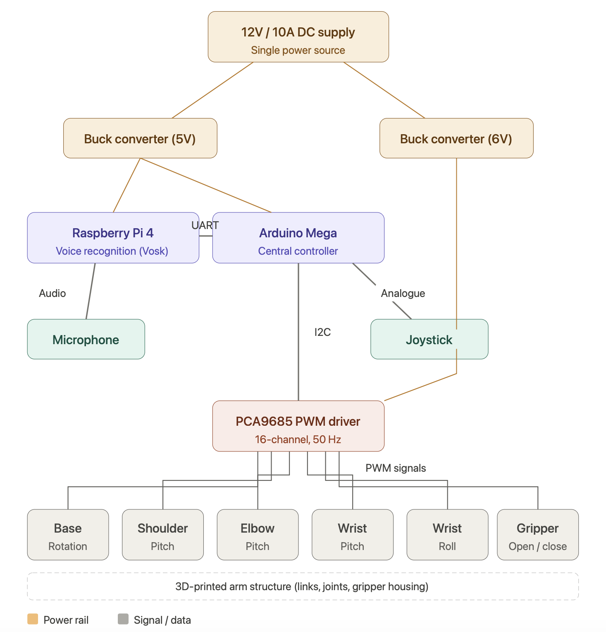

System Block Diagram
Power Supply Subsystem
The whole system runs off a single 12V, 10A DC power supply. Two buck converters are used to bring the voltage down to the levels needed by each subsystem. The first one steps the 12V down to 6V to power the servo motors through the PCA9685 PWM driver board. This gives the motors enough voltage for high-torque operation while staying within their safe limits. The second buck converter steps the 12V down to 5V to power both the Raspberry Pi 4 and the Arduino Mega. Using one power source with multiple output rails like this keeps the wiring simple and makes sure all subsystems share a common ground reference.
Dual Control Input Subsystem
The system takes two types of user input: voice commands and joystick input. Having two input options gives users flexibility depending on how much mobility they have.
For voice control, a microphone connected to the Raspberry Pi 4 captures audio input. The Pi runs the Vosk offline speech recognition engine, which processes everything locally without needing an internet connection. Once a valid voice command is recognised, the Pi parses it into a structured instruction and sends it to the Arduino Mega over a UART serial link. This keeps the Raspberry Pi focused only on speech processing and command dispatch, with no direct role in motor control.
The joystick is connected directly to the Arduino Mega through its analogue input pins. It produces two analogue voltage signals, one for the X-axis and one for the Y-axis, which the Arduino reads using its onboard ADC. This gives a fast, reliable manual control option that works completely independently from the voice recognition side.
Dual-Controller Processing Unit
The Arduino Mega is the central controller of the system. It monitors two input sources at the same time: the UART interface for parsed voice commands coming from the Raspberry Pi, and the analogue pins for joystick readings. Depending on which input is active at any given time, the Arduino works out the target position for each of the six joints and produces the corresponding control signals. It then communicates with the PCA9685 PWM driver board over I2C, sending the calculated pulse-width values for each servo channel.
Motor Driver and Actuation Subsystem
The PCA9685 is a 16-channel PWM driver board. It receives position commands from the Arduino via I2C and generates the 50Hz PWM signals needed to position each servo motor. The reason for using this board is that it takes PWM generation off the Arduino entirely. If the Arduino had to generate six PWM signals simultaneously while also handling serial communication and analogue reads, there would be timing conflicts. With the PCA9685 handling that, the Arduino is free to focus on processing inputs. Each of the six servo motors is connected to its own channel on the PCA9685 and powered directly from the 6V servo rail.
Mechanical Arm Structure
The physical arm has six joints, each driven by a dedicated servo motor. The six degrees of freedom are base rotation, shoulder, elbow, wrist pitch, wrist roll, and gripper. The structural parts of the arm, including the links, joint housings, and gripper assembly, are all 3D-printed. Using 3D printing makes it easier to customise the shape and dimensions of each link to match the required range of motion and load for the application.
Overall Signal Flow
The signal flow from user input to arm movement follows one of two paths depending on which input is being used.
When a voice command is given, the microphone picks up the audio and passes it to Vosk running on the Raspberry Pi. Vosk processes the audio locally and returns a recognised text string, which the Pi then parses into a structured command and sends to the Arduino over UART. The Arduino decodes the command, maps it to target joint angles, and sends the corresponding PWM values to the PCA9685 over I2C. The PCA9685 then generates the PWM signals on the right channels, driving the servos to their target positions and producing the commanded movement.
When the joystick is used instead, the Arduino reads the analogue voltage levels on the X and Y input pins at regular intervals, maps them to angular displacements for the relevant joints, and sends the resulting PWM values to the PCA9685 over I2C, the same way it handles voice commands. The arm responds to joystick movement in near real-time, giving direct manual control over joint positioning.
In both cases the final step is the same: PWM signals from the PCA9685 drive the servo motors, which move the joints of the 3D-printed arm to produce the desired motion.

3.3 Mechanical Design of the Arm
3.3.1 Arm Structure and Degrees of Freedom
The robotic arm is designed as a six-degrees-of-freedom serial manipulator, meaning all six joints are arranged in a single chain running from the fixed base all the way to the end-effector. This kind of architecture, which can be seen in the CAD model developed in TinkerCAD and shown in Figure 3.2, gives the arm enough workspace coverage and joint flexibility to handle general grasping and pick-and-place tasks without needing the extra mechanical complexity that comes with parallel kinematic structures.
The six degrees of freedom are spread across the arm in the following way. The first DOF is the base joint, which rotates about the vertical axis and lets the arm sweep across the full operating workspace. The second DOF is the shoulder joint, which controls how high or low the upper arm is angled relative to the base. The third DOF is the elbow joint, which governs the angle between the upper arm and forearm. The fourth and fifth DOFs are the wrist pitch and wrist roll joints, and together they allow the end-effector to approach a target object from many different orientations regardless of where the rest of the arm is positioned. The sixth DOF is the gripper, which opens and closes to grasp and release objects. The first five joints each operate over a range of 0° to 180°, while the gripper works over a smaller range of 0° to 90°, where 0° is fully closed and 90° is fully open.
The arm has five rigid links connected in series. The base-to-shoulder riser is 100mm tall, which lifts the shoulder joint high enough to allow the arm to reach all the way down to the mounting surface. The upper arm link from shoulder to elbow is 150mm long. The forearm link from elbow to wrist pitch joint is 135mm. The wrist assembly covering the wrist pitch and wrist roll joints is 60mm, and the gripper assembly from the wrist roll joint to the fingertip is 80mm. When all joints are fully extended, the arm has a maximum reach of about 425mm from the base rotation axis to the fingertip. In its upright resting position the arm stands about 300mm tall. These dimensions give the arm a workspace that works well on a standard wheelchair tray or desktop surface.
3.3.2 Material Selection and Justification
All structural parts of the arm, including the base housing, link bodies, joint enclosures, servo mounting interfaces, and gripper assembly, will be fabricated from Polylactic Acid (PLA) filament using Fused Deposition Modelling (FDM) 3D printing. The CAD models for all the components have been designed in TinkerCAD and are ready to be exported as STL files for printing. PLA was chosen as the material for a few key reasons.
In terms of mechanical properties, PLA has a tensile strength of around 50 MPa and a flexural modulus of about 3.5 GPa. This is strong enough to handle the bending moments and joint reaction forces produced by a 500g end-effector payload across all joint positions. Compared to materials like ABS or PETG, PLA does have lower impact toughness, but that is not really a concern here. The arm will be moving slowly and in a controlled manner on a tabletop, so there is no high-impact loading to worry about. What actually matters more for this application is stiffness, and PLA's higher stiffness-to-weight ratio helps reduce elastic deflection along the links under load, which would otherwise cause positional error at the end-effector.
From a practical standpoint, PLA is also the easiest FDM material to work with. It prints reliably at nozzle temperatures between 190°C and 220°C, sticks to a standard print bed without needing an enclosure, and does not warp the way ABS does. In an academic project setting where print reliability and material availability matter, these are significant advantages.
Another reason PLA works well here is that it allows complete freedom in the geometry of each component. Every link profile, joint housing, servo mounting pocket, and gripper finger curve in the TinkerCAD model can be printed exactly as designed, without being constrained by whatever shapes off-the-shelf hardware kits come in. This is especially important for the gear-driven gripper assembly, where the spur gear geometry requires precise dimensional accuracy that would be very difficult to achieve through any other fabrication method at this project scale.
For structurally critical areas, particularly the servo horn mounting interfaces at each joint and the gear teeth on the gripper fingers, a print infill density of at least 40% is specified to ensure adequate strength. Link bodies and non-load-bearing housing walls can be printed at 20 to 25% infill, which reduces material use and print time without affecting structural performance.
3.3.3 Gripper and End-Effector Design
The end-effector is a gear-driven two-finger parallel jaw gripper, as shown in the TinkerCAD model in Figure 3.2. It is actuated by a single servo motor and uses a spur gear mechanism to keep both fingers moving together. Each finger has a spur gear at its base, and the two gears mesh directly with each other so that when the servo turns one gear, both fingers move at the same time in equal and opposite directions. This gear coupling ensures that both jaw fingers always move symmetrically about the centreline of the gripper no matter what object is being grasped, which is important for reliable centred grasping.
This gear-driven design was chosen over a simpler single-linkage mechanism because a linkage-only design can cause one finger to contact an object before the other, resulting in an asymmetric, unreliable grip. The gear teeth, which are visible in the TinkerCAD model, use a standard module profile to ensure smooth motion and adequate tooth strength within PLA's material limits.
The gripper servo operates from 0° to 90°, where 0° is fully closed and 90° is fully open. At the fully open position, the jaw opening is about 80mm, which is wide enough to grip common everyday objects like cups, bottles, and remote controls. The curved finger profile shown in the model provides a contact shape that conforms better to cylindrical and irregular objects compared to flat jaw faces, which improves grip stability.
The gripping force at the jaw faces depends on the servo's stall torque and the gear ratio. For a servo with a stall torque of about 10 kg·cm at 6V and a gear pitch radius of 15mm, the theoretical clamping force at the fingertip is around 65N. This is well above the 4.9N minimum needed to hold a 500g object against gravity, even after accounting for friction losses in the gear mesh.
The entire gripper assembly mounts to the wrist roll servo horn through a standardised interface, so the end-effector can be detached and replaced without disturbing the rest of the arm.
3.3.4 Mechanical Assembly
The arm is assembled as a series of modular joint-link units built up from the base, which matches the structure shown in the three views of the TinkerCAD model in Figure 3.2. Each unit consists of a 3D-printed structural link, a servo motor sitting inside a purpose-designed housing cavity, and the mechanical interface to the next joint.
The base is a large cylindrical housing with a flat bottom for stable surface mounting. It has a flange with mounting holes so it can be attached to a wheelchair tray or desktop using bolts or adhesive pads. The base rotation servo sits inside the cylinder with its output shaft pointing vertically upward to drive the first rotational DOF. The shoulder riser link connects directly to the base servo output horn and raises the shoulder joint to the 100mm design height above the mounting surface.
Each link further up the arm connects to the joint below it by fitting its proximal mounting socket onto the servo output horn of the lower joint and securing it with a retaining screw. The servo body at each joint is enclosed within the 3D-printed housing of the preceding link and is held in place by a friction fit combined with M3 machine screws through the servo mounting ears. Keeping the servo motors enclosed inside the arm structure gives the arm a clean overall profile and protects the servo bodies from accidental contact during operation, which is reflected in the smooth outer surfaces visible in the model.
The wrist assembly attaches to the forearm link in the same way, and the gripper base plate connects to the wrist roll servo horn as the final assembly step. Servo signal and power cables are routed through longitudinal channels printed into the interior of the link bodies where the geometry allows, and are secured with printed clip features on the outer surfaces where internal routing is not possible. All six servo cables come together at the base, where they connect to the PCA9685 PWM driver board mounted next to the base housing.
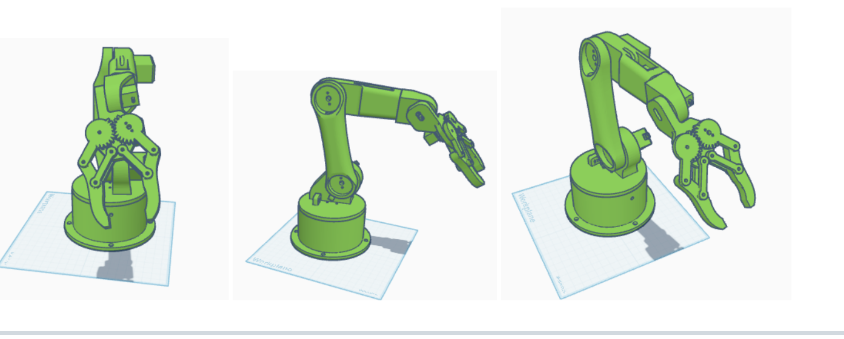
The complete arm, printed at the specified infill densities, is estimated to weigh between 850g and 1.0kg in total. This falls within the rated load capacity of the base rotation servo and is consistent with a portable, surface-mounted assistive device.
CAD model of the assistive robotic arm

3.4 Control Input System Design
3.4.1 Description of the Input Devices
The system takes two independent forms of user input: a dual-axis analogue joystick assembly for direct manual joint control, and a voice command interface for higher-level natural language control. Both input channels work in parallel but handle different aspects of the control task. The joystick gives continuous, real-time control over the arm's primary movement joints, while the voice interface handles fine-positioning commands and higher-level tasks like gripper operation and the autonomous pick-and-place routine.
The manual input side uses two standard two-axis analogue joystick modules. Each module produces independent X-axis and Y-axis voltage signals based on how far the thumbstick is physically deflected. Together the two modules give four analogue control axes, which are mapped to four of the arm's five non-gripper joints as follows: the left joystick X-axis controls base rotation, the left joystick Y-axis controls shoulder elevation, the right joystick X-axis controls wrist lateral movement, and the right joystick Y-axis controls elbow bend and extension. Wrist roll and gripper operation are left to voice commands, since those actions are better suited to deliberate, discrete input rather than continuous analogue deflection. Both joystick modules connect directly to the analogue input pins of the Arduino Mega.
The voice input side uses a USB microphone connected to the Raspberry Pi 4. The Pi runs the Vosk offline speech recognition engine, which processes audio locally without needing an internet connection. The full list of recognised voice commands is shown in Table 3.1.
Spoken phrase | Command token | Action
"base left" | BASE LEFT | Rotate base anticlockwise
"base right" | BASE RIGHT | Rotate base clockwise
"shoulder up" | SHOULDER UP | Elevate upper arm
"shoulder down" | SHOULDER DOWN | Lower upper arm
"elbow bend" | ELBOW BEND | Decrease elbow angle
"elbow extend" | ELBOW EXTEND | Increase elbow angle
"wrist left" | WRIST LEFT | Rotate wrist laterally left
"wrist right" | WRIST RIGHT | Rotate wrist laterally right
"wrist up" | WRIST UP | Pitch wrist upward
"wrist down" | WRIST DOWN | Pitch wrist downward
"rotate left" | ROTATE LEFT | Roll wrist anticlockwise
"rotate right" | ROTATE RIGHT | Roll wrist clockwise
"open gripper" | OPEN GRIPPER | Open jaw to 90°
"close gripper" | CLOSE GRIPPER | Close jaw to 0°
"pick and place" | PICK AND PLACE | Execute autonomous routine
Table 3.1: Defined voice command vocabulary
3.4.2 Working Principle of the Input Sensors
Each analogue joystick module has two 10kΩ potentiometers inside it, one for the X-axis and one for the Y-axis, both mechanically linked to the thumbstick. Deflecting the stick in any direction rotates both potentiometers proportionally. Each potentiometer is wired as a voltage divider between 5V and ground, so as the thumbstick moves away from centre, the wiper on the corresponding potentiometer shifts along the resistive track and produces a voltage that varies linearly between 0V and 5V. When the stick is at rest in the centre position, each axis sits at about 2.5V, which represents the neutral or zero-displacement condition.
The voice input path works quite differently. The USB microphone continuously picks up audio and streams it to the Vosk engine running on the Raspberry Pi. Vosk uses a pre-trained acoustic model and language model to perform continuous speech recognition completely offline. When the recognised text matches one of the defined command tokens in Table 3.1, the Pi encodes the command as a structured ASCII string and sends it to the Arduino Mega over the UART serial interface at a baud rate of 9600. The Arduino receives and parses this string inside its main control loop and executes the corresponding joint action.
3.4.3 Signal Conditioning and ADC Interface
The four joystick axis voltages are read by the Arduino Mega through its onboard 10-bit successive approximation ADC. The ADC converts the voltage on each analogue pin to an integer between 0 and 1023, where 0 corresponds to 0V and 1023 corresponds to 5V. At the neutral joystick position, each axis gives a reading of about 512. The four joystick axes are connected to analogue pins A0 through A3 on the Arduino Mega.
No external signal conditioning is needed for the joystick inputs because the potentiometer output voltage is already within the 0V to 5V input range of the Arduino ADC, and the source impedance of the voltage divider is low enough to drive the ADC sample-and-hold input without significant voltage droop. A software dead-band filter is applied in firmware around the neutral reading of 512, rejecting values in the range 492 to 532 as mechanical centre noise. This stops the joints from drifting when the joystick is just sitting at rest.
The UART serial link between the Raspberry Pi and the Arduino Mega involves a logic level mismatch since the Pi operates at 3.3V while the Arduino runs at 5V. To handle this, a two-resistor voltage divider level shifter is placed on the Raspberry Pi TX line before it reaches the Arduino RX pin, bringing the 3.3V signal up to a 5V-compatible level. The Arduino TX line connects directly to the Raspberry Pi RX pin because the Arduino's 5V TX output falls within the overvoltage tolerance of the Raspberry Pi GPIO when that pin is configured as an input.
3.4.4 Mapping Input Values to Arm Movement
Joystick mapping. The raw ADC reading from each joystick axis is mapped to a continuous joint velocity command rather than a direct angle setpoint. When the joystick is deflected beyond the dead-band, the Arduino increments or decrements the current target angle of the corresponding joint by a fixed step size on each iteration of the control loop. The direction depends on whether the ADC reading is above or below 512; readings above 532 increment the joint angle and readings below 492 decrement it. The step size is set to 1° per control loop iteration, which gives smooth continuous joint motion for as long as the joystick stays deflected. As soon as the joystick returns to neutral, motion stops. Soft angle limits are enforced in firmware so that all joints stay within 0° to 180° and the gripper stays within 0° to 90°, preventing any command from driving a servo past its mechanical range.
Voice command mapping. Voice commands produce discrete joint actions rather than continuous motion. When a directional command like WRIST LEFT is received, the Arduino starts incrementing or decrementing the target angle of the relevant joint by 1° per control loop iteration and keeps going until either a STOP command comes in or the joint hits its angle limit. This mirrors the continuous motion behaviour of the joystick but is triggered and stopped by spoken commands instead of physical deflection. Absolute position commands like OPEN GRIPPER and CLOSE GRIPPER drive the gripper servo directly to 90° or 0° without needing a follow-up STOP command. The PICK AND PLACE command triggers a pre-programmed sequence of joint angle waypoints that the Arduino executes on its own without any further user input.
Priority arbitration. If joystick input is active on a given joint at the same time as a voice command targeting that same joint, the joystick takes priority. At the start of every control loop iteration, the Arduino checks for joystick deflection on each joint axis before it processes anything in the UART serial buffer. If a joystick axis is outside its dead-band for a given joint, any voice command targeting that joint is ignored for that iteration. This makes sure the operator can always override voice-driven motion with direct physical joystick input, which matters for user safety in a real-time assistive setting.

3.5 Embedded System Design
3.5.1 Microcontroller Selection and Justification
The Arduino Mega 2560 was chosen as the central embedded controller for this system. It is based on the ATmega2560 microcontroller running at 16MHz and comes with 54 digital I/O pins (15 of which support hardware PWM), 16 analogue input channels, 256KB of flash memory, 8KB of SRAM, and four independent hardware UART serial ports.
The reason for going with the Mega 2560 instead of the more common Arduino UNO R3 comes down to the specific I/O demands of this project. The system needs four analogue input channels for the dual joystick assembly, one dedicated hardware UART for communication with the Raspberry Pi, one I2C bus for the PCA9685 PWM driver, and enough digital I/O for any additional status outputs. The Arduino UNO only has 6 analogue inputs, 14 digital I/O pins, and one hardware UART that is shared with the USB programming interface. When all the peripherals for this project are connected at the same time, the UNO is essentially at or beyond its limit. More specifically, on the UNO the hardware UART pins 0 and 1 are shared with the USB-to-serial chip used for programming, so having an active UART link to the Raspberry Pi blocks the USB serial monitor entirely. That is a real problem during firmware development and debugging.
The Mega 2560 takes care of all of these issues comfortably. Its four hardware UARTs mean the Raspberry Pi link can use Serial1 on pins 18 and 19 while Serial0 stays free for USB debug output. Its 16 analogue channels handle the four joystick axes on A0 to A3 with plenty to spare. Its dedicated I2C pins on pins 20 and 21 connect to the PCA9685 without using up any general-purpose I/O. For all these reasons, the Mega 2560 is the right microcontroller for this project.
3.5.2 Circuit Design
The full system circuit is spread across the Arduino Mega, the PCA9685 PWM driver board, the Raspberry Pi 4, a breadboard used as a common power distribution bus, and two buck converter modules. The wiring schematic is shown in Figure 3.3.
The 12V DC supply connects to the input terminals of both buck converters through the breadboard power rails. The first buck converter is set to output 6V and connects to the V+ and GND power input terminals of the PCA9685 board, providing regulated power to the servo motors. The second buck converter is set to 5V and supplies both the Arduino Mega through its VIN pin and the Raspberry Pi 4 through its 5V GPIO pin or USB-C power input.
The PCA9685 communicates with the Arduino Mega over I2C. The SDA line of the PCA9685 connects to pin 20 (SDA) on the Arduino and the SCL line connects to pin 21 (SCL). The PCA9685 logic supply (VCC pin) is powered from the Arduino's 3.3V output. Each of the six servo motors connects to a dedicated channel on the PCA9685 output header: base servo on channel 0, shoulder on channel 1, elbow on channel 2, wrist pitch on channel 3, wrist roll on channel 4, and gripper on channel 5. Each servo connector carries three wires, signal (orange), power (red, 6V from the PCA9685 rail), and ground (brown).
The dual joystick modules connect to the Arduino Mega analogue inputs. Left joystick VRx goes to A0 and VRy to A1. Right joystick VRx goes to A2 and VRy to A3. Both modules share the Arduino's 5V and GND pins for supply.
The Raspberry Pi UART TX pin (GPIO14) connects through the voltage divider level shifter to the Arduino Mega Serial1 RX pin (pin 19). The Arduino Mega Serial1 TX pin (pin 18) connects directly to the Raspberry Pi UART RX pin (GPIO15). Both boards share a common ground through a wire between their respective GND pins. The USB microphone plugs into one of the Raspberry Pi's USB-A ports.
Note on current schematic: The wiring schematic diagram in Figure 3.3 currently shows the Arduino connecting directly to the servo motors without the PCA9685 in between. This will be corrected in the updated schematic to be produced in semester 2, which will show the PCA9685 correctly placed between the Arduino I2C bus and the servo signal lines. The text description above reflects the intended and correct circuit topology.
3.5.3 Power Supply Design
The whole system runs from a single 12V DC supply rated at a minimum of 10A continuous output. This supply is distributed to two separate voltage rails using two DC-DC buck converter modules, each regulated to the voltage needed by its subsystem.
The servo power rail is set to 6V. This voltage was chosen because standard hobby servos in the MG996R class deliver their rated stall torque of about 10 kg·cm at 6V, compared to only about 8.5 kg·cm at 4.8V. With six servos each drawing a worst-case average of 700mA under simultaneous load, the maximum current demand on the servo rail is 4.2A. The buck converter on this rail therefore needs to be rated for at least 5A continuous. The PCA9685 board also has a 1000µF bulk capacitor on its servo power input, which absorbs the instantaneous current spikes that happen when servos start up or change direction quickly, protecting the buck converter from overcurrent faults.
The logic power rail is set to 5V and supplies both the Raspberry Pi 4 and the Arduino Mega. The Pi draws up to 1.5A under full CPU load during speech recognition, and the Arduino draws about 200mA including the PCA9685 logic supply. Total logic rail current demand is therefore around 1.7A, so the buck converter on this rail needs to be rated for at least 2.5A to have enough margin. Both rails share a common ground tied to the negative terminal of the 12V supply.
The 12V supply itself can either be a regulated 12V DC mains adapter, which is recommended for bench-top use, or a 12V lithium polymer battery pack for portable or wheelchair-mounted use. If the battery option is used, a 3-cell (3S) LiPo pack with a capacity of at least 3000mAh and a continuous discharge rating of 10A or higher is needed to sustain the system through a typical operating session without voltage sag affecting servo performance.
3.5.4 Firmware and Software Design
The firmware on the Arduino Mega is structured as a single continuous main loop that runs the same sequence of operations on every iteration. A flowchart of the firmware architecture is shown in Figure 3.4.
During initialisation, the firmware sets up the I2C bus and initialises the PCA9685 driver library, setting the PWM frequency to 50Hz across all 16 channels. It also initialises Serial1 at 9600 baud for UART communication with the Raspberry Pi and sets all six joint angle variables to their defined home position values. The arm is then commanded to the home position on startup.
On each main loop iteration, the firmware starts by reading the ADC values from all four joystick analogue inputs and applying the dead-band filter. For any axis reading outside the dead-band, the corresponding joint angle variable is incremented or decremented by the defined step size and the new angle is immediately written to the PCA9685 over I2C, which produces the corresponding servo movement. Joints whose joystick axes are within the dead-band are not updated from the joystick on that iteration.
The firmware then checks the UART serial buffer for any incoming data from the Raspberry Pi. If a complete command string has been received, it is compared against the command vocabulary table. If the command targets a joint that is not currently under active joystick control, it is executed: directional commands start incrementing or decrementing the target joint angle on each subsequent loop iteration until a stop condition comes in, and absolute commands like OPEN GRIPPER drive the target joint directly to its specified angle. If the command targets a joint that is currently being deflected by the joystick, the command is discarded for that iteration in line with the joystick priority rule.
The PICK AND PLACE command is a special case. It bypasses the normal per-joint control logic and hands over execution to a dedicated subroutine that drives the arm through a predefined sequence of joint angle waypoints: approach, descend, close gripper, ascend, transfer, descend, open gripper, and retract. There is a configurable dwell time at each waypoint to give the servos enough time to complete their movement before the next command is issued.
All joint angle variables are clamped to their defined limits on every write operation, which are 0° to 180° for joints 1 through 5 and 0° to 90° for the gripper. This acts as a firmware-level safety boundary that stops any command from driving a servo past its mechanical range regardless of where the command came from.

3.6 Simulation
3.6.1 Simulation Tool Used
The kinematic behaviour and control logic of the assistive robotic arm were validated through simulation in Webots, an open-source robot simulation platform developed and maintained by Cyberbotics. Webots provides a physics-based 3D simulation environment where robot models can be loaded, positioned, and controlled through user-written controller programs. It supports several programming languages for controller development including Python, C, C++, Java, and MATLAB, and comes with a large library of pre-built robot models that can serve as simulation proxies for custom designs.
Webots was chosen as the simulation platform for this project for a few reasons. To start with, it is free and open-source, so there are no licensing issues in an academic project setting. More importantly for this project, Webots natively includes the Niryo Ned robot model, which is a 6-DOF desktop collaborative arm whose joint configuration, specifically base rotation, shoulder, elbow, wrist pitch, wrist roll, and gripper, maps directly onto the joint architecture of the arm designed in this project. This made the Niryo Ned a very suitable simulation proxy, allowing the team to validate joint movement ranges, pick-and-place logic, and command response behaviour without needing a physical prototype. Webots also has a built-in console for real-time programme output, which was used to display the active command vocabulary and track system state during simulation runs.
3.6.2 What Was Simulated
The simulation was set up to validate three things. First, the full pick-and-place task sequence, which is the primary functional objective of the arm, was simulated to confirm that the 6-DOF joint configuration is sufficient to reach a target object on a tabletop, close the gripper around it, move it to a second location, and release it. Second, the joint-level movement response to the defined voice command vocabulary was simulated by mapping keyboard keys to the equivalent command tokens, which replicated the discrete command-driven joint control behaviour that will be implemented in the physical system through voice input. Third, the operating environment of the arm, a tabletop surface with a target object placed at a reachable position, was modelled to reflect the intended real-world deployment context.
The simulation did not cover the electronic subsystems, the PCA9685 PWM driver behaviour, or the UART communication between the Raspberry Pi and Arduino. Webots works at the kinematic and task level rather than the circuit level, so those aspects are addressed separately through the wiring schematic described in Section 3.5.2.
3.6.3 Simulation Setup and Parameters
The simulation scene was built inside the Webots world editor. The Niryo Ned robot model was loaded from the Webots built-in robot library and placed on a rectangular table object at the centre of the simulation environment, as shown in Figure 3.5. A cylindrical rod object representing the target item to be grasped was placed on the table surface at a fixed position within the arm's reachable workspace. The positions and orientations of the robot, table, and object were defined using Webots translation and rotation parameters in the world coordinate frame.
The robot controller was written in Python and ran inside the Webots controller runtime environment. Rather than specifying continuous motion profiles with defined velocities, the controller worked by commanding each joint to a target angle in degrees and letting the Webots physics engine handle the actual movement to that position. This is consistent with the position-control firmware architecture described in Section 3.5.4, where the Arduino commands servo positions through the PCA9685 rather than specifying velocity profiles.
Keyboard inputs were mapped to the full command vocabulary defined in Table 3.1, with each key press producing a discrete step change in the target angle of the corresponding joint. This replicated the incremental, step-based joint motion that the physical system will produce in response to both joystick deflection and voice commands. The simulation console printed the active command list at startup and echoed each command token to the output window as it was executed, giving a real-time record of the command sequence during each simulation run.
The pick-and-place sequence was carried out by manually issuing the joint commands needed to position the gripper over the target object, descend to grasping height, close the gripper, retract, rotate the base to the placement position, descend again, open the gripper, and retract back to the home position.
3.6.4 Simulation Results
The simulation successfully showed that the Niryo Ned robot, running under the step-based joint command architecture described above, can execute a complete pick-and-place task within a tabletop environment. The arm was commanded from its home position to a grasp posture over the target rod object, the gripper was closed around it, and the arm transported the object to a second location on the table where it was released. The entire task was completed without any joint limit violations and without the arm links colliding with the table surface at any point in the sequence.
Figure 3.5 shows the Webots simulation environment with the Niryo Ned arm on the table and the console panel displaying the active voice command vocabulary. The console output confirms that all fifteen command tokens defined in Table 3.1 were successfully recognised and mapped within the simulation controller, and the arm is shown in an extended reach posture consistent with the approach phase of the pick-and-place sequence.
The results validate two key design assumptions. First, the 6-DOF joint configuration provides enough degrees of freedom and range of motion to achieve all the postures required for the pick-and-place task within a tabletop workspace. Second, the step-based command-driven joint control architecture, where each command produces a discrete angular increment held until a stop condition is issued, produces joint motion that is smooth and controllable enough for practical pick-and-place manipulation without needing continuous trajectory planning or inverse kinematics in the controller.
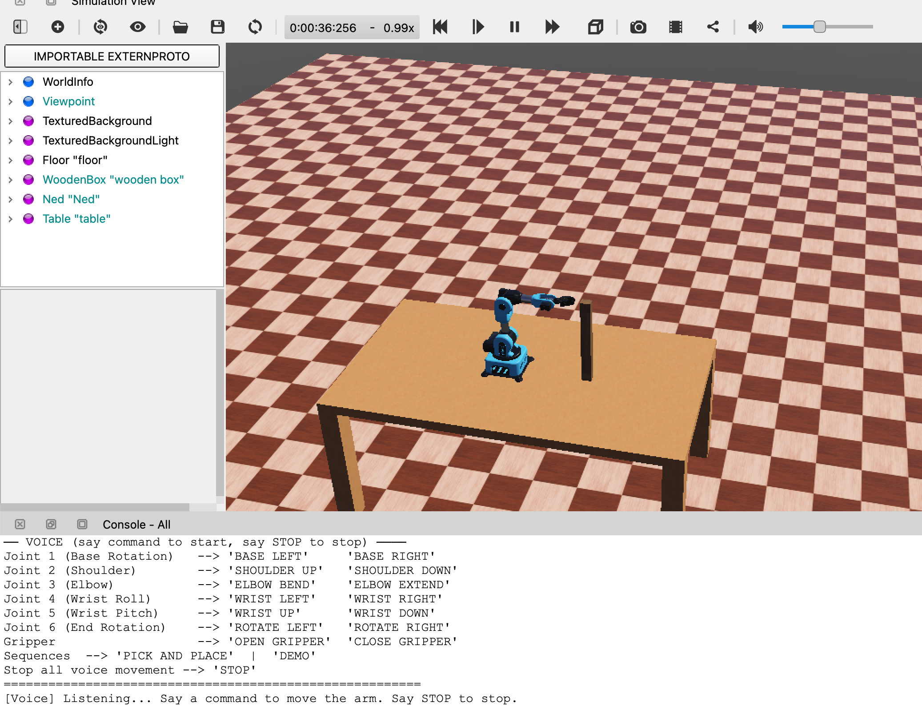
These results give a reasonable level of confidence that the proposed physical system, once built and programmed in semester 2, will be able to replicate the demonstrated behaviour in hardware.

Figure 3.5: Webots simulation
3.7 System Integration
The work done in the first semester of this project covers three distinct engineering areas: mechanical design, electronics design, and software simulation. Each of these has produced a concrete deliverable. The mechanical design has been completed in TinkerCAD, producing a fully detailed 3D model of the six-degree-of-freedom arm structure, joint housings, and gear-driven gripper assembly that is ready for FDM 3D printing. The electronics design has been completed as a wiring schematic that defines the connections between the Raspberry Pi 4, Arduino Mega, PCA9685 PWM driver, dual joystick modules, buck converters, servo motors, and the 12V power supply. The control logic and task behaviour have been validated through the Webots simulation, where the full pick-and-place sequence and the complete joint command vocabulary were successfully demonstrated using the Niryo Ned as a kinematic proxy.
System integration at this point in the project is really about showing that these three deliverables are consistent with each other and together describe one coherent system. The arm modelled in TinkerCAD uses the same six-degree-of-freedom joint architecture as the Niryo Ned model used in the Webots simulation: base, shoulder, elbow, wrist pitch, wrist roll, and gripper. The joint angle ranges used in the simulation controller, which are 0° to 180° for the five primary joints and 0° to 90° for the gripper, are the same ranges enforced in the firmware architecture described in Section 3.5.4 and correspond to the physical servo travel that the PCA9685-driven servos will produce in the actual hardware. The command vocabulary implemented in the Webots Python controller and listed in Table 3.1 is exactly the same command set that the Raspberry Pi Vosk engine will recognise and transmit to the Arduino in the physical system. The wiring schematic accounts for all the components needed to realise in hardware the control pipeline that was validated in simulation.
The three deliverables therefore represent the mechanical, electrical, and behavioural specifications of the same system, just described from three different angles. No physical prototype has been assembled by the end of semester 1 because the project timeline puts hardware fabrication, firmware development, and system testing in semester 2. The integration work of semester 1 has instead produced a complete design specification for the semester 2 build to implement.
In semester 2, physical integration will be done in stages. The 3D-printed structural components will be fabricated and assembled with the servo motors to produce the mechanical arm. The electronics will be assembled on a breadboard and then on a custom mounting plate following the wiring schematic, with the PCA9685 correction noted in Section 3.5.2 incorporated into the updated schematic. The Arduino firmware described in Section 3.5.4 will be written and tested on its own first, verifying servo response to direct angle commands, before being integrated with the joystick input and the Raspberry Pi UART link. The Raspberry Pi voice recognition pipeline will also be tested independently using the Vosk engine before being connected to the Arduino serial interface. Full system integration testing will then verify that voice commands and joystick inputs produce the correct joint movements on the physical arm, and the pick-and-place sequence demonstrated in simulation will be replicated on the hardware prototype.

